Southern Alberta institute of Technology

Project Workshop6: Networking

by

**Femi Adams**

Winter 2023

**Configuring Listener.ora File**

**Directory**

Listener.ora file can be found in $ORACLE HOME\NETWORK\ADMIN directory C:\Oracle\db\19c\network\admin\listener.ora on the server

**Steps to configuring Listener.ora file**

* Add your hostname or dns name of the server the database is on. In this case I used dns name but you can check for hostname by typing >hostname in cmd line.
* Add the port number the listener is listening on. I used the default port number 1521.
* Save the file and open cmd prompt
* Use the listener command utility LSNRCTL to get into listener
* Start the listener using START key word
* Check the status of listener using STATUS keyword.
* Ensure that the listener is running and configured properly on the server.

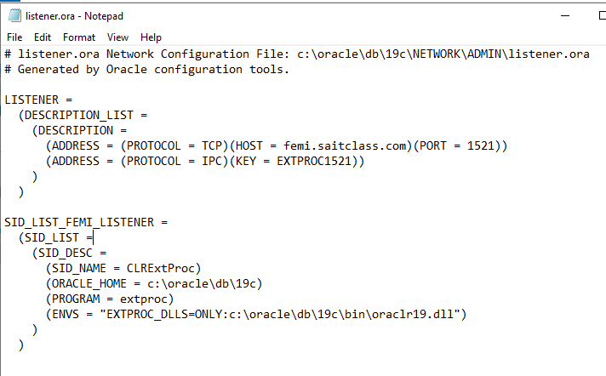

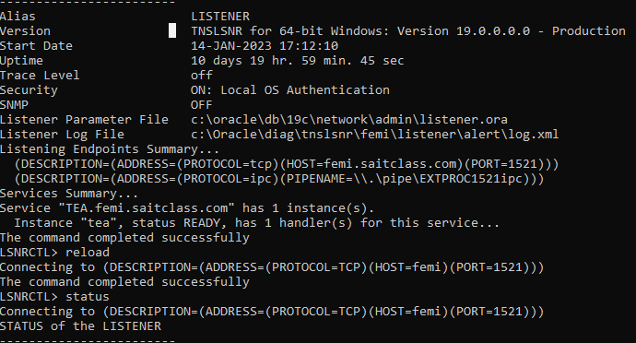

**Configuring Tnsnames.ora File**

**Directory**

Tnsnames.ora file can be found in $ORACLE HOME\NETWORK\ADMIN directory C:\Oracle\db\19c\network\admin\tnsnames.ora

**Steps to configuring tnsnames.ora**

* Ensure that the listener is running on the server side
* Then on the client side, make sure that the Oracle client software is installed and running
* Create a tnsnames.ora file in the clients$ORACLE HOME\NETWORK\ADMIN directory
* Input the server’s hostname/dns name and port number and save the file

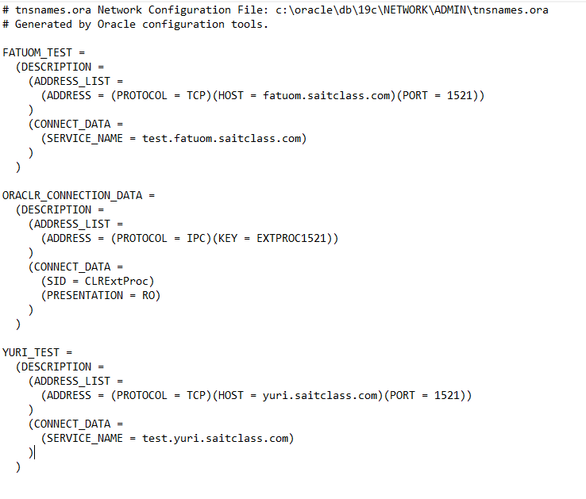

**Configuring Sqlnet.ora File**

**Directory**

Sqlnet.ora file can be found in $ORACLE HOME\NETWORK\ADMIN directory C:\Oracle\db\19c\network\admin\sqlnet.ora

**Steps to configuring sqlnet.ora**

* Create a sqlnet.ora file in $ORACLE HOME\NETWORK\ADMIN directory
* Input the information in the screenshot below.
* Open cmd prompt and set sid to service name of the server database.
* Enter username and password as system/Password1@tea

****(could not perform this test because the dns in class is down)***

* You can slo use a tnsping utility to test the connection.

